ANNUAL EXAM [2022 – 2023]
Class: IX [Aptitude] Date: 17/02/2023 MM: 25
Section A
- Choose the correct answer from the following questions. (1x9=9)
Q1) Select the nearest alternative the meaning of the word “Acute”.
A)Rice B)Accident C)Severe D)Curious
Q2) Select the word or phrase that is most closely opposite meaning of word “moist”.
A)Crisp B)Herd C)Dry D)Parched
Direction for questions 3 to 5
These questions are based on the information given below: 6 girls are sitting in a circle Ashima is sitting opposite to Anita. Amita is sitting right of Anita but left of Mandeep. Suhasini is sitting right of Ashima and left of Namita.
Q3) Who will be opposite to Mandeep?
A)Suhasini B)Ashima C)Anita D)Namita
Q4) Who are the neighbours of Suhasini?
A)Namitha and Ashima B) Anita and Mandeep
C) Namitha and Anita D) Amita and Ashima
Q5) who is sitting right of Suhasini?
A)Mandeep B)Ashima C)Anita D)Namita
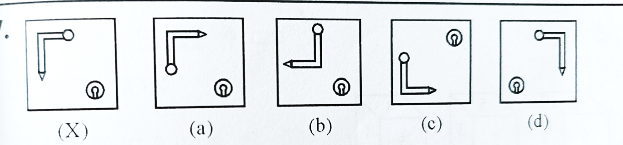
Q6) Choose the correct mirror image:

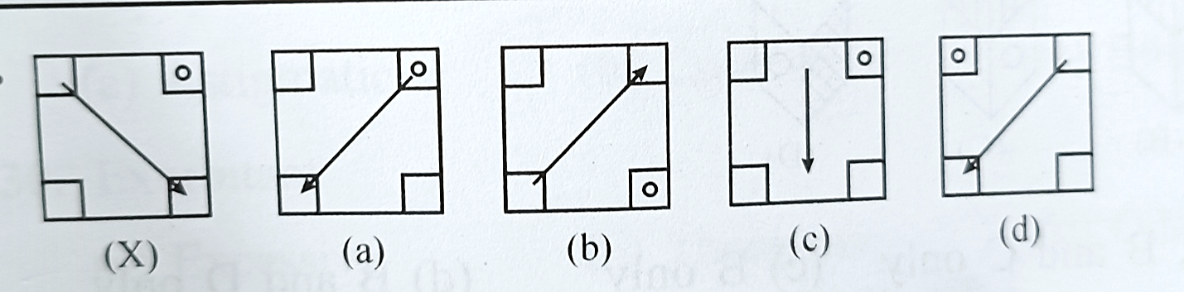
Q7) choose the correct water image:
Q8)Loudness of sound depends upon
- Intensity of sound C) Sensitiveness of the earyea
- Both A and B D) None of the above
Q9) The president of the World bank has always been from
- UK B) U.S.A. C) France D) Russia
Section B
- Answer the following: (Any 8) (2x8=16)
Q10) His life consists of________ of drinking punctuated by periods of drunken sleep.(fill the suitable word)
Q11) When the morning ________ the murder was discovered. (Fill the suitable word)
Q12) Name the places in Orissa where some starvation deaths have been reported?
Q13) How many people in India live in poverty?
Q14) Which type of colloid is milk?
Q15) What is the valency of an element with a complete octet in its outermost shell?
Q16) Most serious threat to ozone shield in the atmosphere is?
Q17) Factorise 49a^2 – 25b^2 + 1 – 14a
Q18) The volume of hemisphere of radius 6 cm is?
Q19) What is the rationalizing factor of (√5 - √2)

